CHAPTER 12: FILE HANDLING IN PYTHON
TOPICS COVERED:
12.1 HOW PYTHON HANDLES A FILE
12.2 TYPES OF FILE
12.3 FILE HANDLING ACCESS MODES
12.4 FILE HANDLING OPERATIONS

12.1 HOW PYTHON HANDLES A FILE
- Python provides lot of features to handle data or information stored with in a file to be used for reading specific data from a file or writing data in to a file.
- In common, programming languages offers variables to store these values within it during execution time and these data will be lost once the program execution is completed.
- In order to use these data further we use file handling concepts in python.
- Python offers different built in functions and methods to handle file data which are non volatile since it is stored in a file for lateral use.

12.1 TYPES OF FILE
In general there are two types of variables available. There are,
- Binary File – common system files with a specific format which cannot allow the user to read its content.
Example:
  - Document files & Image files
  - Video files & Audio files
  - Database files & Archive files
  - Executable files

- Text file – These files cannot have any restrictions and it will open in all normal text editors.
Example:
- Web standards: html, XML, CSS, JSON etc.
- Source code: c, app, js, py, java etc.
- Documents: txt, tex, RTF etc.
- Tabular data: csv, tsv etc.
- Configuration: ini, cfg, reg etc.
12.3 FILE HANDLING ACCESS MODES
Mode | Description
‘r’ | Used for reading data from a specific file. This is one of the default mode.
‘w’ | Used to write data into a specific file, if the file already exists.
‘a’ | Used to append new information with existing information of a file.
‘r+’ | Used for both reading and writing data within same file
‘w+’ | Used for writing new info if file already exists otherwise creates a new file with same given name and writes data in to it. Also used to overwrite the existing data in a specific file if it is exist.
‘a+’ | Used for both reading and appending data within a same file
‘wb’ | Used for writing only binary information
‘rb’ | Used to read only binary files and binary information from a file

12.4 FILE HANDLING OPERATIONS
Python file handling allows the following 6 types of operation for performing data manipulation in a script. There are,
- Open ()
- Read ()
  - Read (n)
  - Readline(n)
  - Readlines()
- Write ()
  - Write(string)
  - Writelines(list)
- Close ()
- Rename ()
- Delete ()

[Note: open – is used to open new file or an existing file
Read – is used to read overall content of a file.
Readline – is used to read contents line by line.
Readlines – used to display remaining lines of content in list comprehension fashion.
Write – is used to write new information into a file.
Writelines – used to write list of items in to a file.
Close – used to close a opened file so that all the above changes will be invoked in a file.
Rename – used to rename a file using os module
Delete – used to delete a file in python.
For all the above mentioned functions, python file object is mandatory to perform these actions]
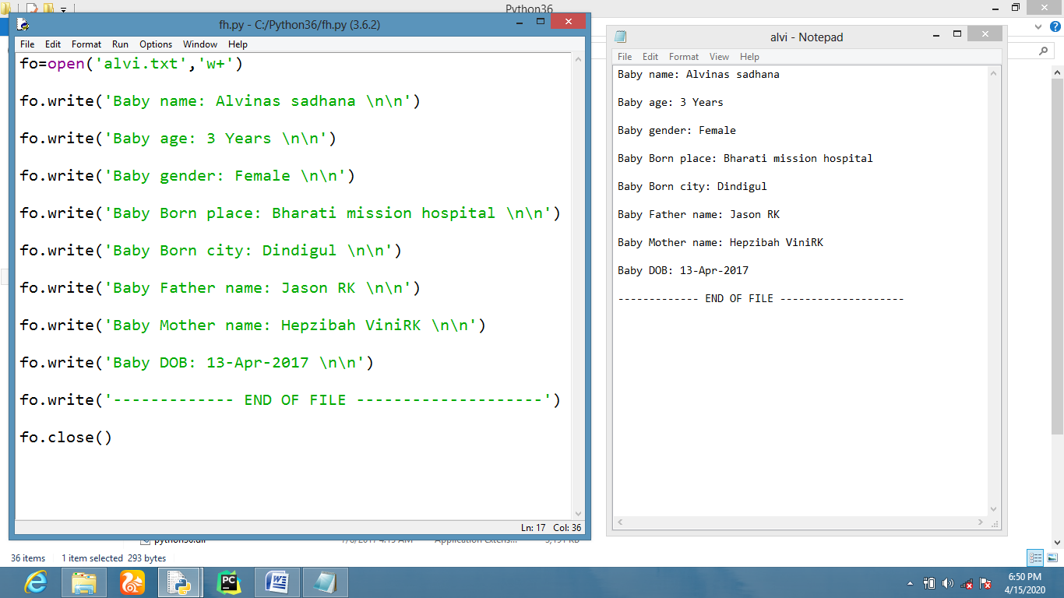
READING DATA FROM A FILE
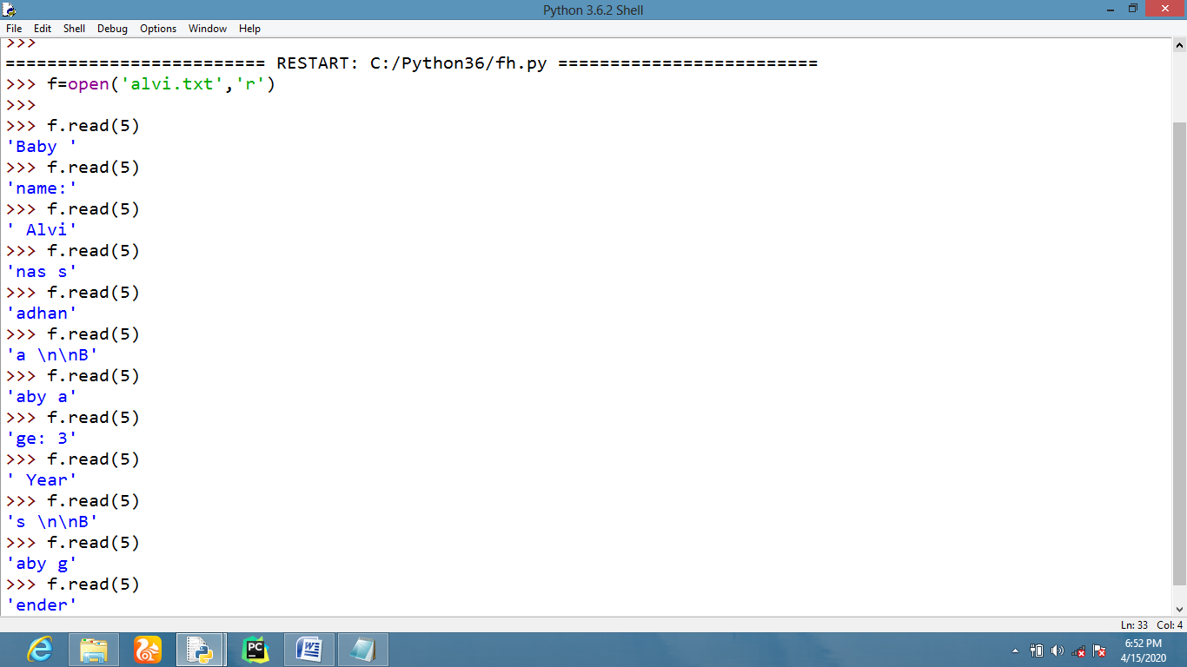
READING DATA LINE BY LINE FROM A FILE
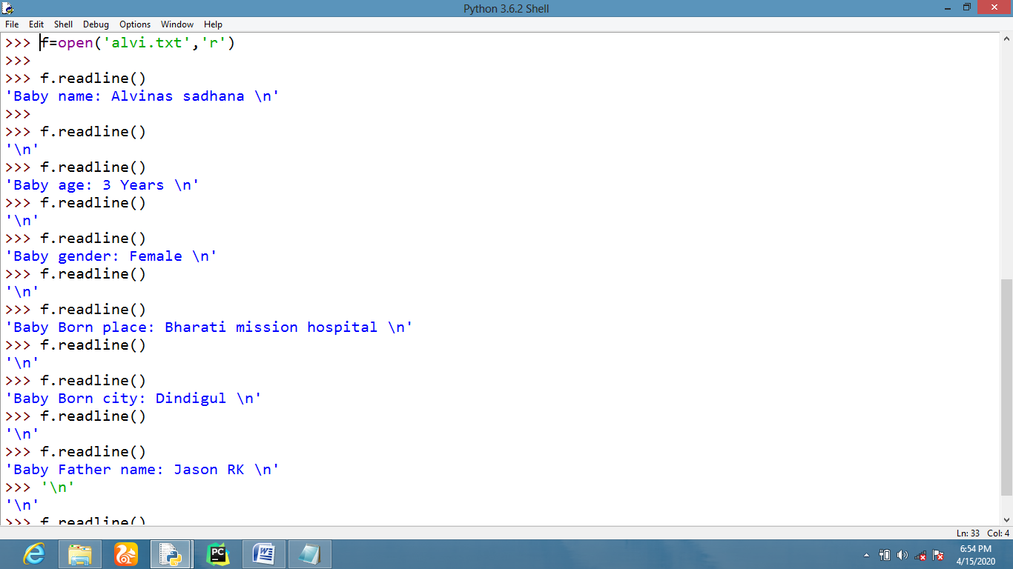
READING DATA USING READLINES
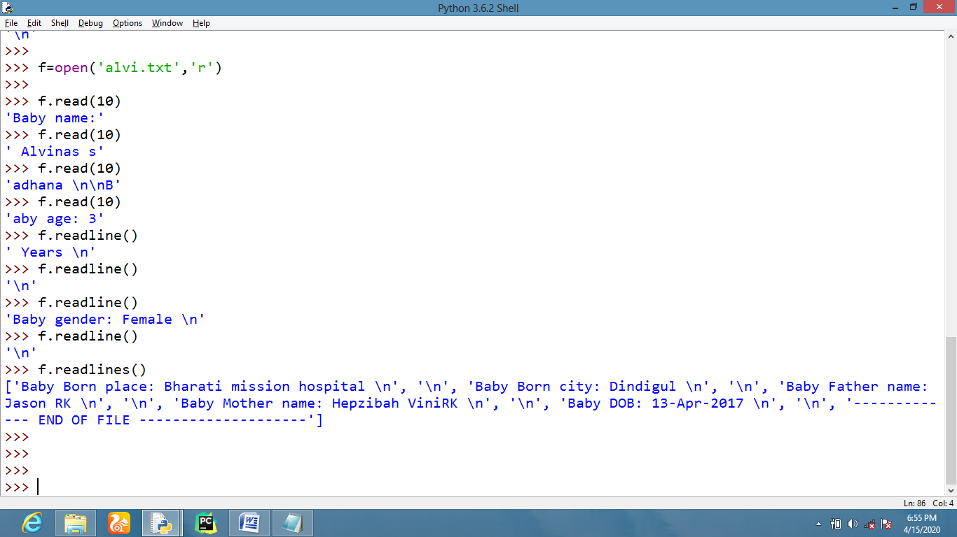
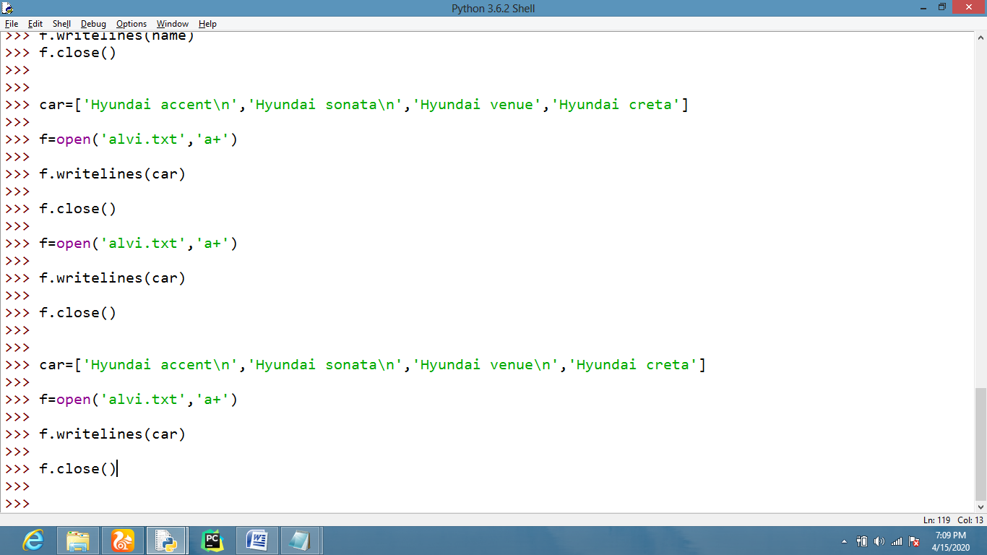
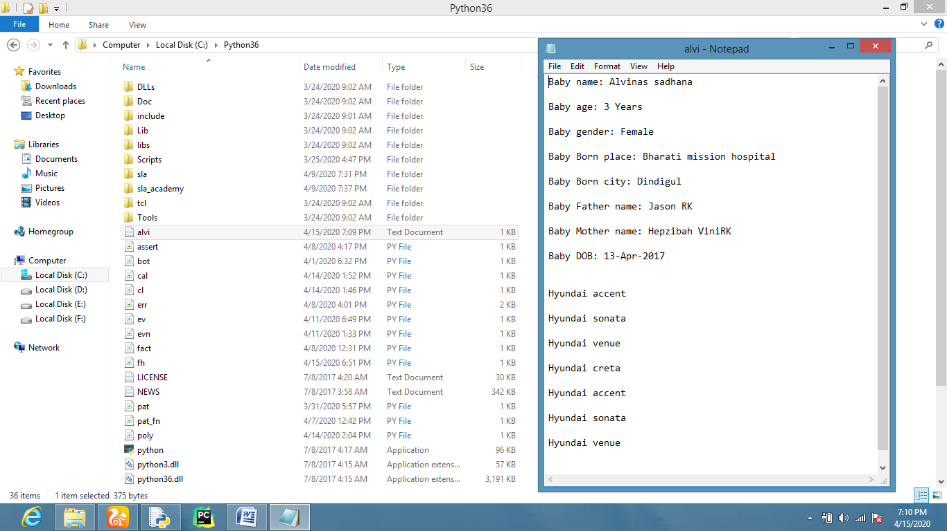
OVERWRITING DATA IN A FILE
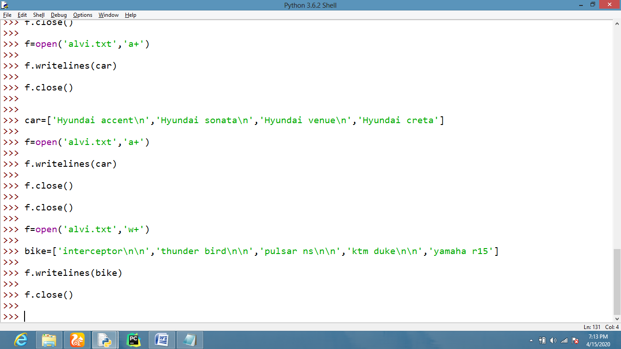
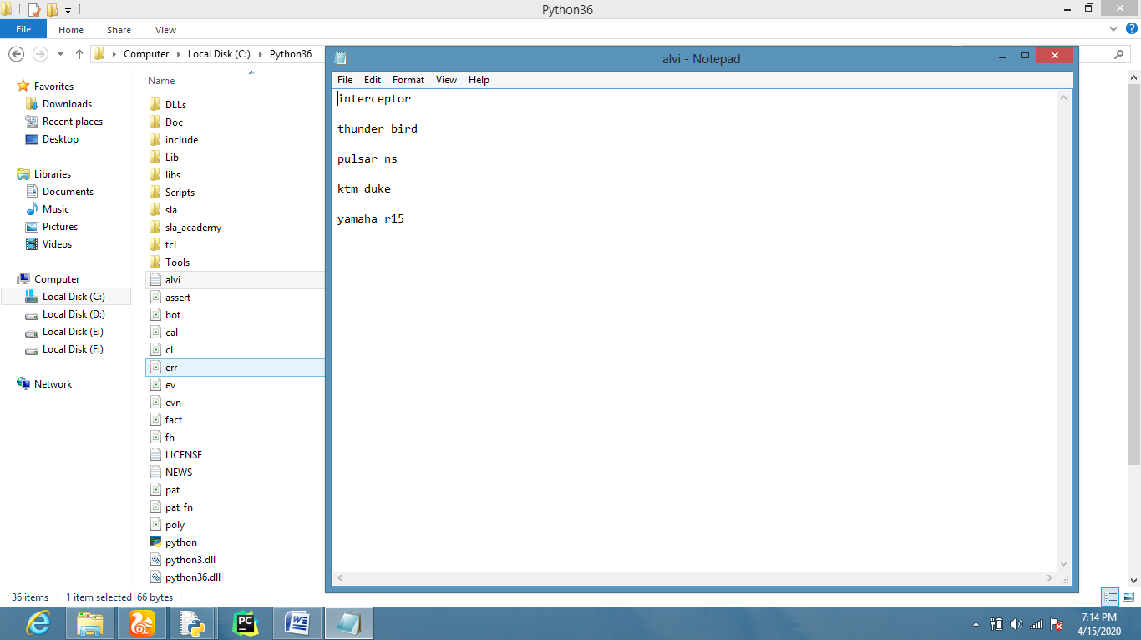
TO CHECK WHERE THE FILE POINTER (CURSOR) IN FILE
